CURRICULUM VITAE

MICHELLE VAN DER WESTHUIZEN
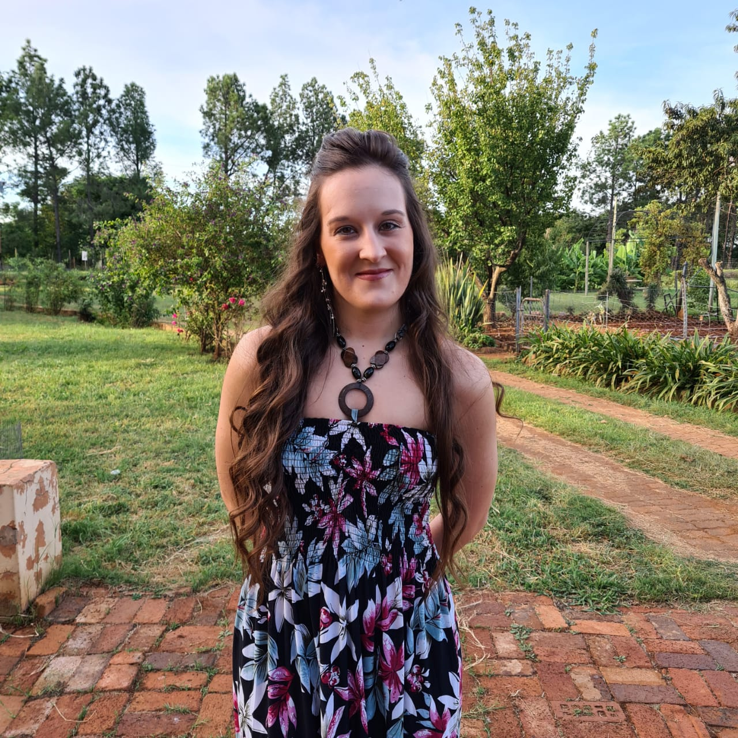

About me

Attitudes Strengths
Energy and drive Extrovert
Passionate Dedicated
Practical Honest
Adaptable to change Organised
Approachable Logical reasoning
Logic in decision making Problem solving
Persuasive Eager to learn new skills
High drive and competitive Non-smoker & drinker
Responsible

Contact Details

Address:
Garsfontein, Pretoria

Email:
cawoodmimi@gmail.com
michellevdw2021@gmail.com

Language

Home language: Afrikaans
Other language: English

Hobbies

- Exercising
- Hiking
- Reading

Introduction

I’m someone who believes in hard work, responsibility, and honesty. I’m pretty stoked about diving into the world of software development and expanding my skill set. Always on the lookout for new challenges, I love pushing myself to grow and improve in whatever I do. I genuinely enjoy working and take pride in giving my best to achieve goals. I want to ensure that I benefit the Company that I work for.

Education

- Matriculated in 2013
- Nature Management NQF5
- Programming Foundation NQF4
- Systems Development NQF5 (current part-time)
Certifications

- DP – 900 Microsoft Azure Data Fundamentals 2022
- 98 – 381 Introduction to Programing Using Python 2022
- 98 – 382 Introduction to Programing Using JavaScript 2023
- 98 – 383 Introduction to Programing Using HTML & CSS 2023
- AZ-204 Developing Solutions for Microsoft Azure 2023

Skills Highlights

- Good communication skills
- Teamwork
- Self-management
- Learning
- Computer Skills

Experience

- 2019 - current ICO - Accounting Solutions – Administrator / Clerk
- 2018 - 2019 Uni-Vision – Personal assistant / Administrator
- 2016 - 2017 Ray Cammack Shows – Game attendant
- 2015 Letsatsi la Africa – Animal caretaker


CURRICULUM VITAE

MICHELLE VAN DER WESTHUIZEN

SECONDARY QUALIFICATIONS

Grade 12 Matriculated in 2013 at the Montana High School, in Pretoria.

Major subjects: Afrikaans
English
Mathematics
Life Orientation
Tourism
Hospitality studies
CAT (All basic MS Office packages as per NQF level 3.

TERTIARY QUALIFICATIONS

Institute: Centurion Academy, Pretoria

Year of study completion: 2014

Qualification level: Nature management NQF5

Major Subjects: Wildlife Diseases
Soil Science
Ecology
Game Ranch Management
Conservation Communication
Animal Science
Field Management
Conservation Development

Institute: CTU Training Solutions

Year of study completion: 2022 - 2023

Qualification level: Systems Development NQF4

Major Subjects: Principles of Program Design
Computer Architecture
Digital Literacy & Proficiency
Programming with Python
Core Web Development
Robotics Development
Ethics & Network Architecture
Cloud Fundamentals


CURRICULUM VITAE

MICHELLE VAN DER WESTHUIZEN

Institute: CTU Training Solutions

Year of study completion: 2023 – current (Part-time)

Qualification level: Systems Development NQF5

Major Subjects: Beginner Java
Programming with C#
Solutions Development
Developers and Operations Engineering
Advanced Java
Business Programming


CURRICULUM VITAE

MICHELLE VAN DER WESTHUIZEN

EMPLOYMENT HISTORY

February 2018 - current
Industry: Accounting

Company: ICO-Accounting Solutions (Pty) Ltd

Position: Administrator / Clerk

Duties: Working on CIPC, SARS and Pastel
Legal administrative work like creating share transfer and certificates.
Working with Trusts.

Reason for leaving: I needed time to find out what career I wanted to pursuit, now I am busy with my studies and seeking growth in the software development field.

February 2018 - 2019
Industry: Time share / Resorts

Company: Uni-Vision

Position: Personal assistant / Administrator

Duties: Research
Capturing slips on Oracle
Arranging payments
Stock taking and ordering
Creating data sheets on excel
Managing and reviewing filing and office system.
Finding suppliers
Reporting on Progress / Follow up on all outstanding project issues
Diary management / Scheduling of meetings
Arrange delivery of correspondence and documents

Reason for leaving: ICO - Accounting Solutions is part of the Uni-Vision group


CURRICULUM VITAE

MICHELLE VAN DER WESTHUIZEN

February 2016 - November 2017
Industry: Carnival
Company: Ray Cammack Shows - In USA
Position: Game attendant
Duties: Set up and tear down of all games.
Cleaning inside and around the games.
Interacting with guest.
Stock ordering, data capturing and management
Training and supervising of temporary workers

Reason for leaving: I wanted to stay in South Africa to start building a life and working on a career.

February 2015 - end June 2015
Industry: Nature and wildlife (game farm)

Company: Letsatsi la Africa

Position: Animal caretaker

Duties: Animal caretaker
Guide
Volunteers orientation and coordination
Guest and reception
Animal darting and group catching

Reason for leaving: Volunteering was fun and exiting but after I started working full time in this field, I realised that I was not suited for this type of work.

Temporary / Volunteer work (2013 - 2014)
Industry: Nature and wildlife (game farm)

Places: Moholoholo wild animal rehabilitation
Ujiji wildlife sanctuary
Mbidi wildlife sanctuary
Lion and Rhino sanctuary
Botswana
Brazen wildlife


CURRICULUM VITAE

MICHELLE VAN DER WESTHUIZEN

References:
Owner of Letsatsi la Africa: Ronell van der Westhuizen
Cell 072 386 8948

ICO Accounting Director: Marten Berkenbosch
Cell: 082 940 3991
Email: Martenb@ico-accounting.co.za

Other references: Can be supplied upon request

Certificates: Can be supplied upon request

